SeeSaw Quadrilaterals Tutorial  Pretend that you are teaching a younger friend or sibling what makes a quadrilateral a quadrilateral. Use the annotate feature on SeeSaw or use pencil and markers to draw as you explain a quadrilateral’s features.  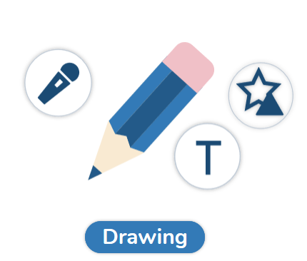 | Make a Quadrilateral Picture  Create an animal, robot or any noun you’d like! Use any materials to create you picture. Make sure to use all different quadrilaterals from our anchor chart.  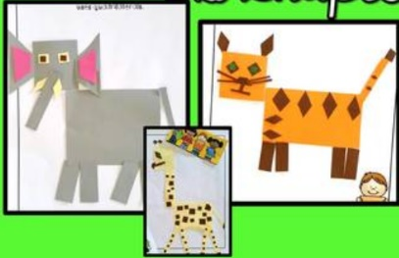  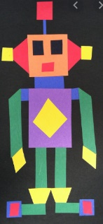 | Interactive Quadrilaterals  Click here to create different quadrilaterals.
Shape Match  Use the instructions for Shape Match to play!  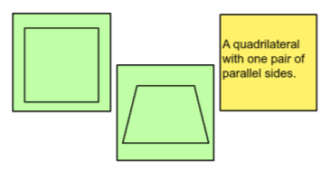 | Freckle  Visit Freckle to practice Geometry.  New password is 4xj7vm | Quadrilateral Riddles  Use the instructions for Quadrilateral Riddles to play! Have a family member guess your quadrilateral!  