How to Download and Login to the MackinVIA App
- Download the free MackinVIA app from your device’s app store.
- Open the MackinVIA app.
- Click on the Sign In Button:
- Type Tritt for the school name and click on “Tritt Elementary, Marietta, GA” when it pops up.
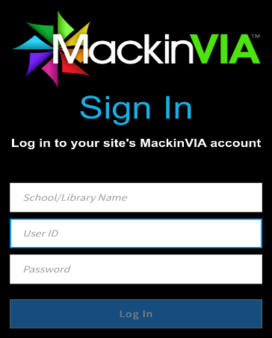
- Click on the Log In button.
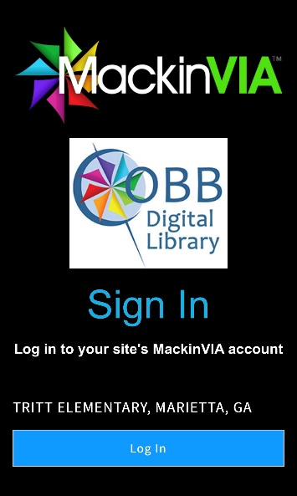
- Enter first.lastname@students.cobbk12.org for username and student number for the password. Then click Sign In
