Logging into the Cobb Digital Library at home:
- Go to www.cobbk12.org
- Click on Parents:
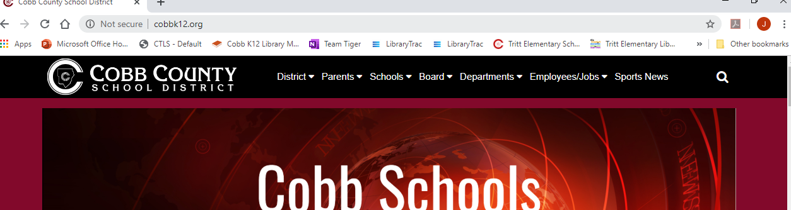
- Choose Cobb Digital Library under Parent Resources:
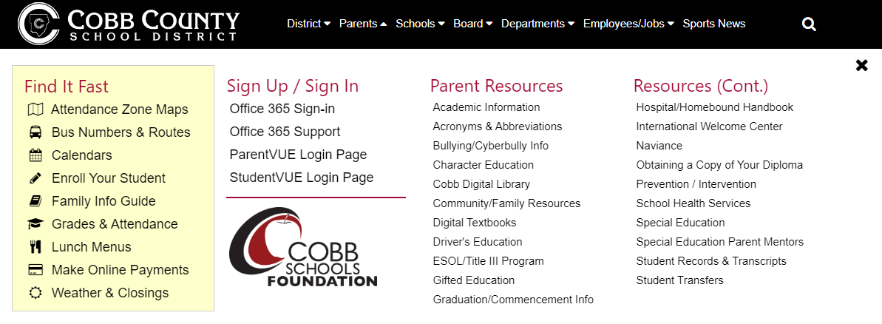
- Click on the Cobb Digital Library symbol:
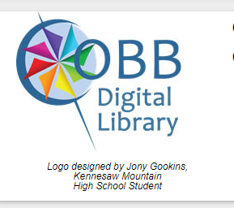
- Type in Tritt for the school name.
- Login with use your Office 365 login (firstname.lastname and computer password).
  - Email Mrs. Bates if you’re not sure of your login: joanne.bates@cobbk1

