Island Conquer!
Directions:
- Both pirates choose a different color pencil or crayon.
- Cut out the coordinate carsd and stack them face down.
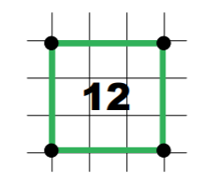
- Pirate 1 chooses a card, plots the coordinates on the map, and connects the points with a colored line. Then find the perimeter and record number inside the “island”
- Pirate 2 checks Pirate 1’s work. If a mistake is found, Pirate 1 crosses out the number on the island and replaces it with 0 to show that the island was not captured.
- Pirate 2 draws out a different card and repeats Step 2 using his or her color. Pirate 1 checks Pirate 2’s work.
- Pirates continue taking turns until the time runs out or all islands have been plotted on the Map.
- At the end of the game, both pirates count their treasure by tallying the total perimeter of all islands. The pirate with the most treasure becomes the Pirate Captain!

