Boom Chick-a-boom

<https://www.youtube.com/watch?v=F2XVfTzel8E>

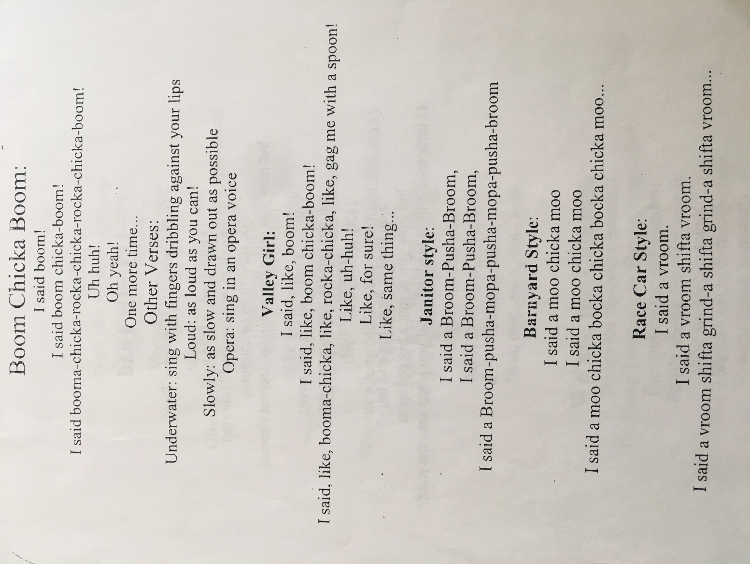

Spong bob campfire song

<https://www.youtube.com/watch?v=_9yhDpVUK3Q>

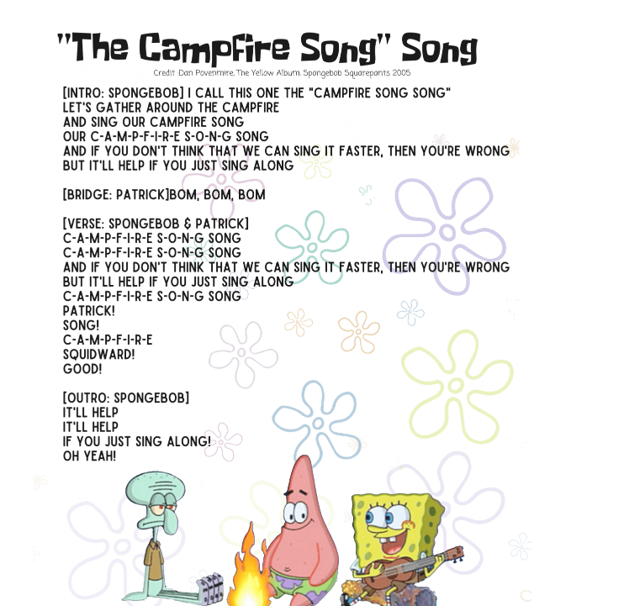

Alice the camel

<https://www.youtube.com/watch?v=AifGElkib0s>

